Review: Compound Light Microscope
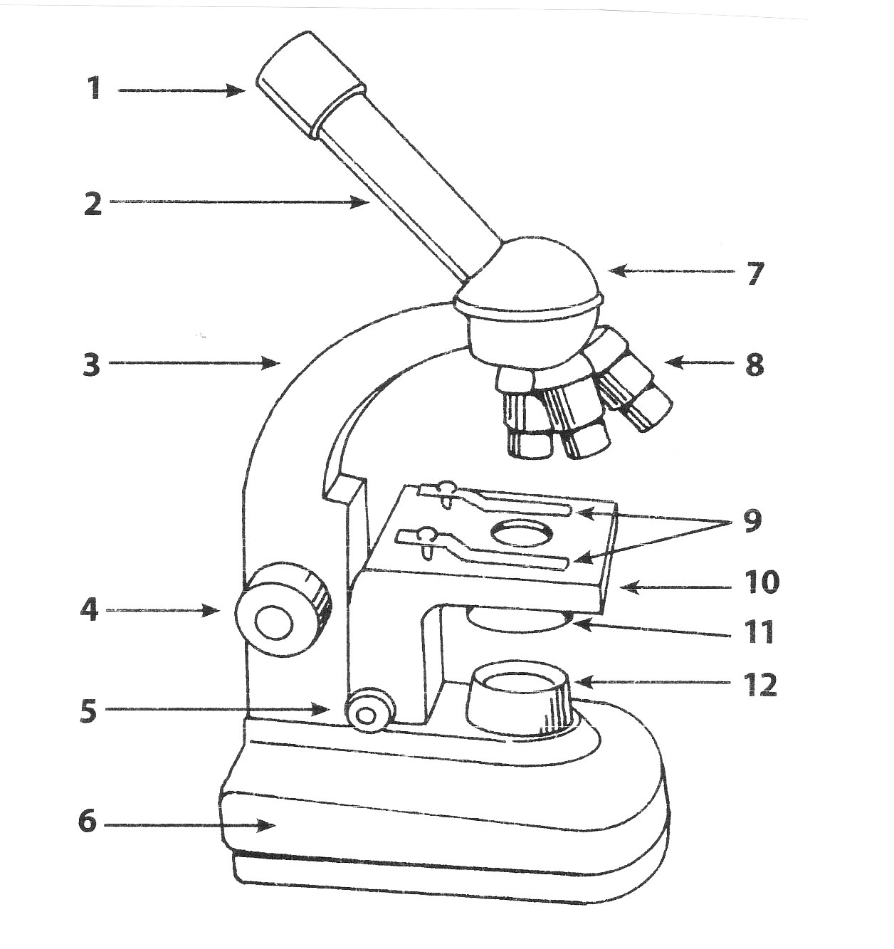
Label the following diagram beside each number.

Complete the following chart on the functions of each part of the microscope:
Label | Name | Function
1
2
3
4
5
6
7
8
9
10
11
12

The Microscope Lab
^{BIOLOGY}
A. Looking at a Letter
In the first part of the lab, you will prepare a wet mount of a letter.
1. Tear a lower case “e”, “f”, “g” or “k” from the paper given. Make a wet mount of the little piece of paper.

Draw how your slide looks before putting it under the microscope (try to use stippling):

2. Use LOW POWER to observe the letter.
Draw the letter, exactly the way it looks through the microscope in the circle (stippling):

LOW POWER

3. Describe the way that an object when viewed through a microscope will be oriented: (ex: right side up, upside down, reversed, forward)
____________________________________

4. When you move the slide on the stage:
a) DOWN, the image through the microscope moves __________

b) UP, the image moves __________

c) LEFT, the image moves ___________

d) RIGHT, the image moves ___________

5. Centre the letter in the field of view, at low power.
Change to MEDIUM power.
Centre the letter again.
DRAW the letter, exactly as you see it.
MEDIUM POWER
6. Change to HIGH power.
DRAW the letter, exactly as you see it.

HIGH POWER

7. Rinse off your slide and coverslip. Dry them and put them away properly to use for next time.

