Reviewing the Periodic Table of Elements
Name:
What to Do
Answer each question in the space provided.

1. (a) Write the symbols for the first 54 elements in the periodic table below. You may want to refer to your periodic table.

(b) Using a yellow pencil crayon, shade the
elements that belong to the group (family) of
alkali metals.
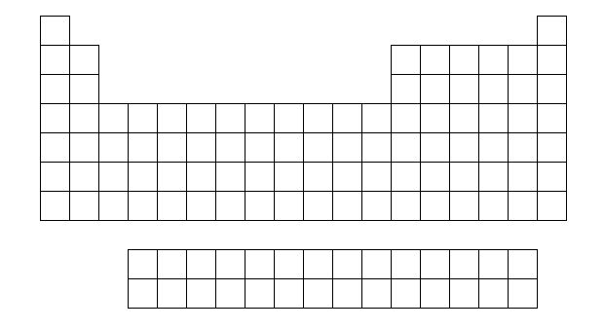

(c) Using an orange pencil crayon, shade the
elements that belong to the group of alkaline
earth metals.

(d) Using a light green pencil crayon, shade the
elements that are part of the halogen group.

(e) Using a light blue pencil crayon, shade the
elements that are part of the noble gas group.

CHAPTER 5

BLM 5-9

Demonstrate your understanding of the basic groups and periods associated with the periodic table of elements:

2. Why are the groups important in the periodic table?
3. What is special about the group of noble gases?
4. Describe two patterns in the periodic table.
5. Describe what happens to the elements in a group as you move vertically down the periodic table (as you go,for example, from an alkali metal in Period 1 to an alkali metal in Period 2).

